SUMMER TRAINING/INTERNSHIP REPORT
(Term Aug-Dec 2026)
Submitted by : Jeevesh Mishra
Registration Number : 12419691
Submitted to :
Mr. Mahipal Singh Papola & Mr. Deepak Kumar
School of Computer Science and Engineering

DECLARATION
I hereby declare that the Summer Training / Internship Report entitled "Drone Delivery Navigation System (SkyShip AI)" is an authentic record of my own work carried out as part of my curriculum for the subject Data Structure and Algorithm Bootcamp for Industry.
This project has been completed under the guidance of Mr. Mahipal Singh Papola and Mr. Deepak Kumar.
I further declare that the work presented in this report has not been submitted by me or anyone else for the award of any other degree or diploma at any University or Institution.
Date: 19/07/2026
Signature of Student
Jeevesh Mishra
Registration No. 12419691

CERTIFICATE

This is to certify that Jeevesh Mishra, bearing Registration Number 12419691, has successfully completed the Summer Training / Internship Project titled "Drone Delivery Navigation System (SkyShip AI)"under our supervision and guidance. This report is submitted in partial fulfilment of the requirements for the subject Data Structure and Algorithm Bootcamp for Industry at Lovely Professional University The work embodied in this report is original and satisfactory.

Mr. Mahipal Singh Papola

Mr. Deepak Kumar

ACKNOWLEDGEMENT
I would like to express my profound gratitude to everyone who supported me throughout this project.
First and foremost, I am deeply indebted to my guide Mr. Mahipal singh and Mr. Deepak Kumar, for their invaluable guidance, constant motivation, and constructive feedback, which were instrumental in the successful completion of this project.
Furthermore, I extend my appreciation to Lovely Professional University (LPU) for providing the comprehensive online training platform and curriculum that made this technical research possible. Finally, I am grateful to my family and friends for their unwavering support and encouragement during this internship and project development phase.

CONTENTS
- Introduction to Organization
- Summer Training Course / Internship Content Detail
- Summer Training / Internship Project Detail
- Problem Statement
- Project Outcomes
- Technologies Used
- System Snapshots
- Future Scope
- Project Links
- Conclusion

INTRODUCTION TO ORGANIZATION
This summer training and project development was conducted online by Lovely Professional University (LPU). LPU is one of India's leading private universities, located in Phagwara, Punjab. Established in 2005 under the Lovely Professional University Act, LPU is recognized for its diverse academic programs, state-of-the-art infrastructure, and focus on innovation, research, entrepreneurship, and industryoriented education.
With a vibrant campus community comprising students from across India and various countries, LPU provides a dynamic learning environment that encourages creativity, collaboration, and holistic development. The university offers a wide range of undergraduate, postgraduate, and doctoral programs across disciplines including engineering, technology, management, sciences, humanities, and many others.
LPU emphasizes practical learning, skill development, and real-world exposure through industry collaborations, research initiatives, student-driven organizations, and various academic and extracurricular activities. The university continues to strive towards creating future-ready professionals equipped with knowledge, skills, and values to contribute effectively to society.

SUMMER TRAINING COURSE / INTERNSHIP CONTENT DETAIL
During the Data Structure and Algorithm Bootcamp for Industry, several important concepts related to software development and problem solving were covered. The primary focus of the training was to understand how efficient algorithms and data structures improve the performance of real-world applications.
The major topics covered during the bootcamp include:
• Introduction to Data Structures and Algorithm Analysis.
• Arrays, Linked Lists, Stacks and Queues.
• Trees, Binary Search Trees and Graphs.
• Graph Traversal Algorithms (BFS and DFS).
• Priority Queue and Heap Data Structure.
• Shortest Path Algorithms including Dijkstra Algorithm.
• Time Complexity and Space Complexity Analysis.
• Hash Maps and Efficient Searching Techniques.
• Problem Solving using JavaScript and TypeScript.
• Building industry-level applications using modern web technologies.
The knowledge gained during this bootcamp was practically implemented while developing the Drone Delivery Navigation System, where Graphs, Dijkstra Algorithm and Priority Queue were used to optimize drone routing and delivery management.

SUMMER TRAINING / INTERNSHIP PROJECT DETAIL
The primary project developed during this Summer Training is Drone Delivery Navigation System (SkyShip AI). The Drone Delivery Navigation System is a web-based application developed to manage drone fleets, optimize delivery routes, monitor deliveries in real time, and improve logistics efficiency using Data Structures and Algorithms. The system provides a user-friendly dashboard for administrators to register drones, assign deliveries, calculate the shortest routes, and monitor drone status.
Project Objective: The objective of this project is to develop a smart drone delivery management system that can efficiently manage multiple drones, optimize delivery routes, reduce delivery time, and improve operational efficiency using Data Structures and Algorithms.

- Drone Registration: The administrator registers drones by entering drone details such as Drone ID, Model, and Payload Capacity.
- Delivery Assignment: Delivery requests are created and assigned to the most suitable available drone.
- Route Optimization: The system calculates the shortest delivery route using Dijkstra's Algorithm while avoiding unnecessary travel distance.Result Analysis:The scan results are analyzed to detect running services, service versions, and firewall behavior based on the port responses..
- Live Delivery Monitoring: The administrator can track the drone's delivery progress, battery level, current mission, and estimated arrival time.
- Analytics & Reporting: The application stores delivery information.

PROBLEM STATEMENT
With the rapid growth of e-commerce and online services, the demand for faster and more efficient package delivery has increased significantly. Traditional delivery methods often face problems such as traffic congestion, longer delivery times, increased operational costs, and inefficient route planning.
Drone-based delivery systems provide a modern solution to these challenges by enabling autonomous aerial transportation of packages. However, managing multiple drones, assigning deliveries, monitoring battery status, and selecting the shortest delivery routes become difficult without an intelligent management system.
Manual planning of delivery routes can result in unnecessary travel distance, increased battery consumption, and delayed deliveries. Therefore, there is a need for an automated Drone Delivery Navigation System that can efficiently manage drone fleets, assign delivery tasks, optimize routes using shortest path algorithms, and monitor delivery operations in real time.
This project aims to solve these problems by providing a centralized platform that combines modern web technologies with Data Structures and Algorithms to improve delivery efficiency and reduce operational complexity.

PROJECT OUTCOMES
- Upon successful implementation, Drone Delivery Navigation System achieved the following outcomes:
- Efficient Fleet Management: The system enables administrators to register, monitor, and manage multiple drones from a centralized dashboard.
- Shortest Route Calculation: Dijkstra's Algorithm helps calculate the shortest delivery path, reducing travel distance and delivery time.
- Improved Delivery Monitoring: Real-time tracking allows administrators to monitor drone status, battery level, mission progress, and estimated arrival time.
- Smart Delivery Assignment: The system efficiently assigns deliveries to available drones based on operational status and capacity.
- Performance Analytics: Interactive dashboards provide insights into delivery success rate, battery usage, active drones, and overall fleet performance.
- Modern User Experience: The responsive interface provides easy navigation, attractive visualizations, and improved usability for drone fleet management.

TECHNOLOGIES USED

Programming Languages: TypeScript , JavaScript

Frontend Technologies: React.js , Tailwind CSS , HTML5 ,CSS3

Backend Technologies: Node.js ,Express.js

Database: MongoDB

Authentication: JSON Web Token (JWT) ,API Communication, Axios

Mapping & Visualization: Mapbox GL JS

Development Tools: Visual Studio Code , Git ,GitHub ,Vercel

Data Structures & Algorithms: Graph, Dijkstra Algorithm, Priority Queue (Heap) Queue, Arrays, BFS & DFS Concepts, Hash Maps

SYSTEM SNAPSHOTS
System Snapshots -
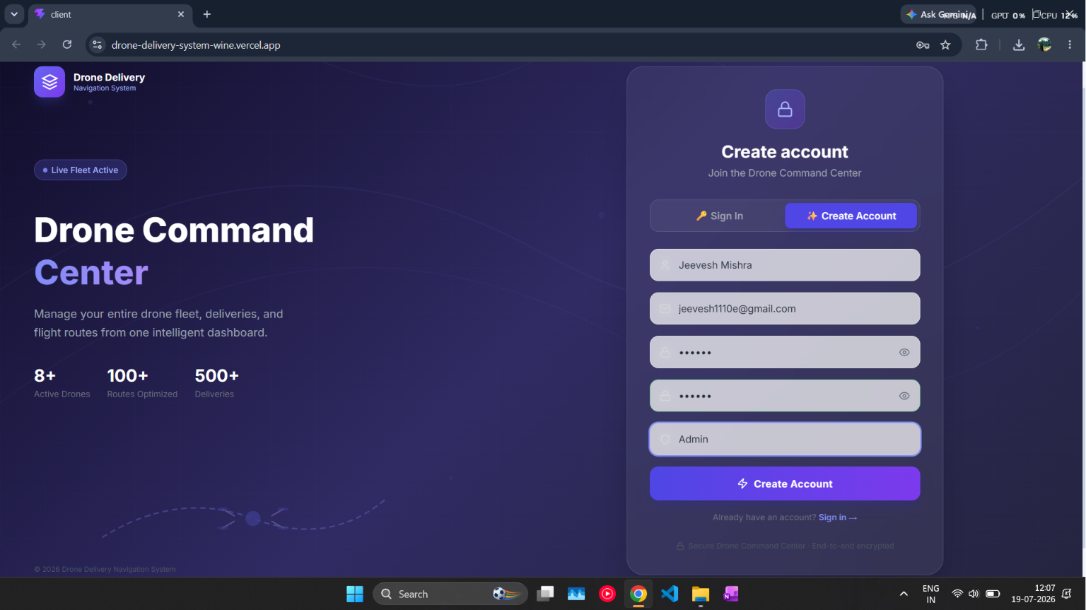
Figure 1.1: Login / Registration Page
Description: This screenshot shows the Login and Registration interface of the Drone Delivery Navigation System. The page provides a secure authentication system that allows new users to create an account and existing users to sign in before accessing the dashboard. The interface includes fields for Full Name, Email Address, Password, Confirm Password, and User Role. A modern dark-themed design has been implemented to provide an attractive and professional user experience. The authentication module ensures that only authorized users can access the system and manage drone operations. User credentials are securely stored in MongoDB, while JSON Web Tokens (JWT) are used to maintain authenticated sessions.
.
Figure 1.2: Dashboard
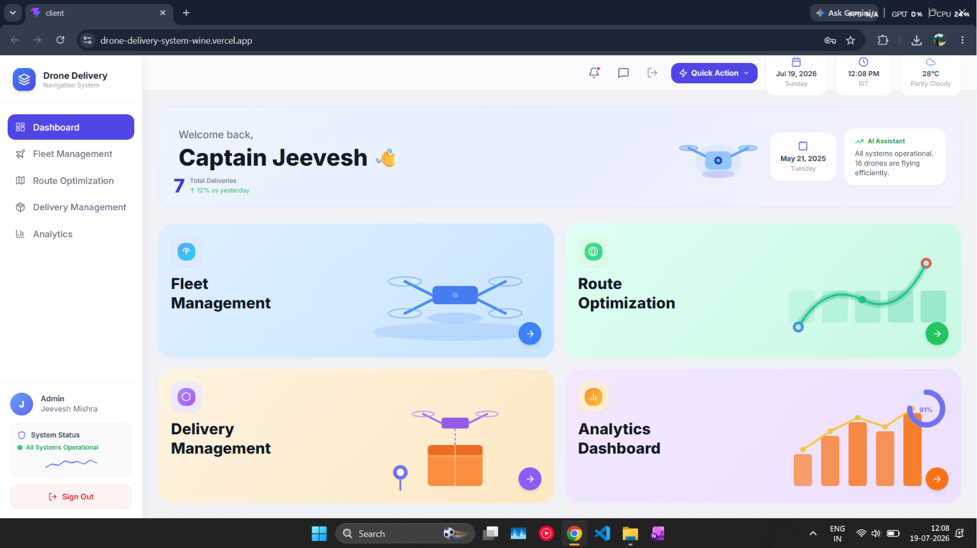

Description: The Dashboard serves as the central control panel of the Drone Delivery Navigation System. It provides administrators with a comprehensive overview of all ongoing drone operations and delivery activities.
The dashboard displays important information including total deliveries, active drones, battery statistics, weather information, and system status. It also provides quick navigation to Fleet Management, Route Optimization, Delivery Management, and Analytics modules.
Interactive cards and summary widgets allow administrators to quickly monitor system performance and access important features. The dashboard is designed using a clean card-based interface with responsive layouts, making it easy to manage drone operations from a single screen
Figure 1.3: Fleet Management
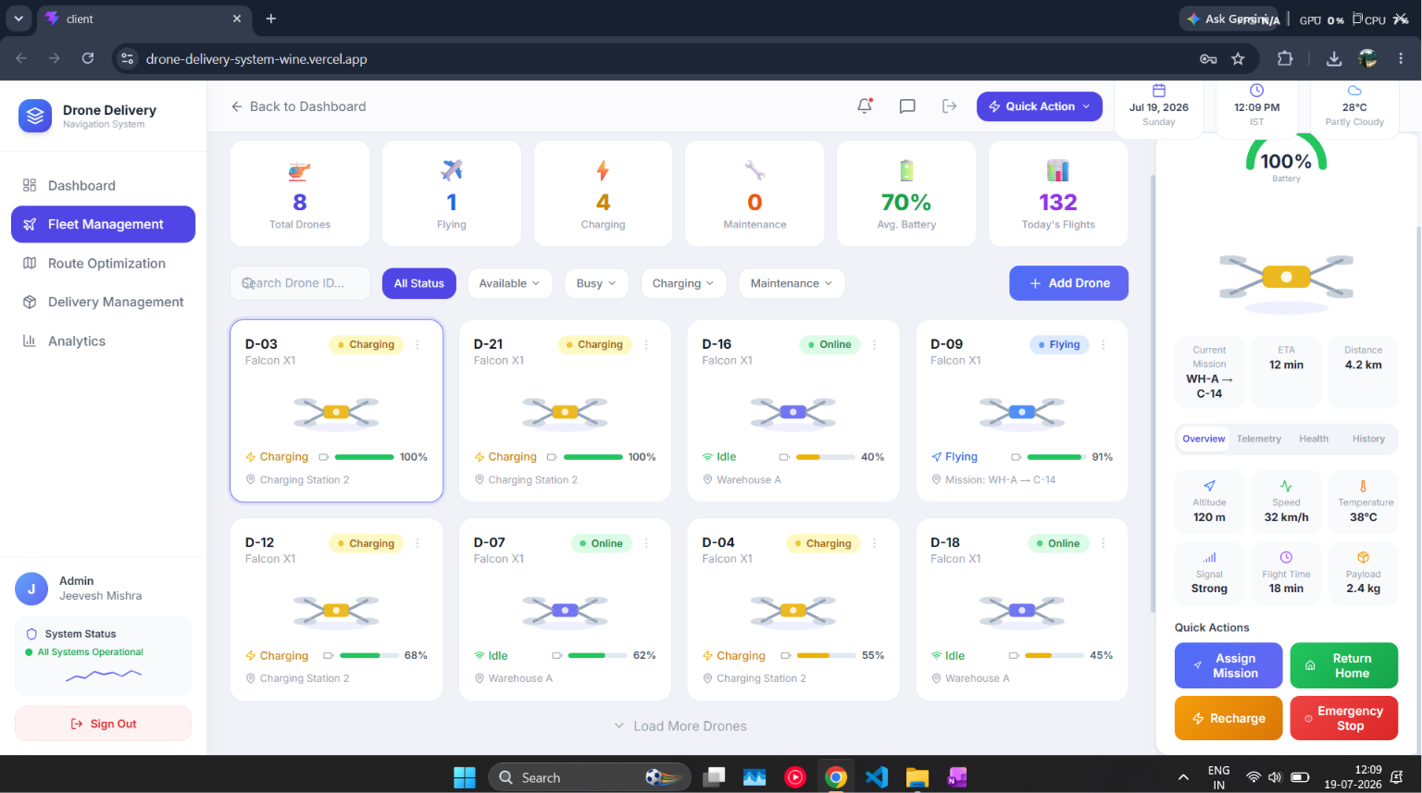
Description: This screenshot shows the Fleet Management Module of the Drone Delivery Navigation System. This module allows administrators to efficiently manage all registered drones from a centralized dashboard.
The page displays detailed information about every drone, including Drone ID, Model Name, Current Status, Battery Percentage, Payload Capacity, Current Location, and Assigned Mission. These details help administrators monitor fleet availability and make quick operational decisions.
Different drone statuses such as Available, In Transit, Charging, and Maintenance are displayed using colored badges for better visibility.
The Fleet Management module also provides options to search drones, filter drones according to their operational status, edit existing drone information, or remove inactive drones from the system.
This module improves operational efficiency by allowing administrators to monitor the complete drone fleet from a single interface while ensuring better resource utilization and delivery planning.
Figure 1.4: Add Drone Window
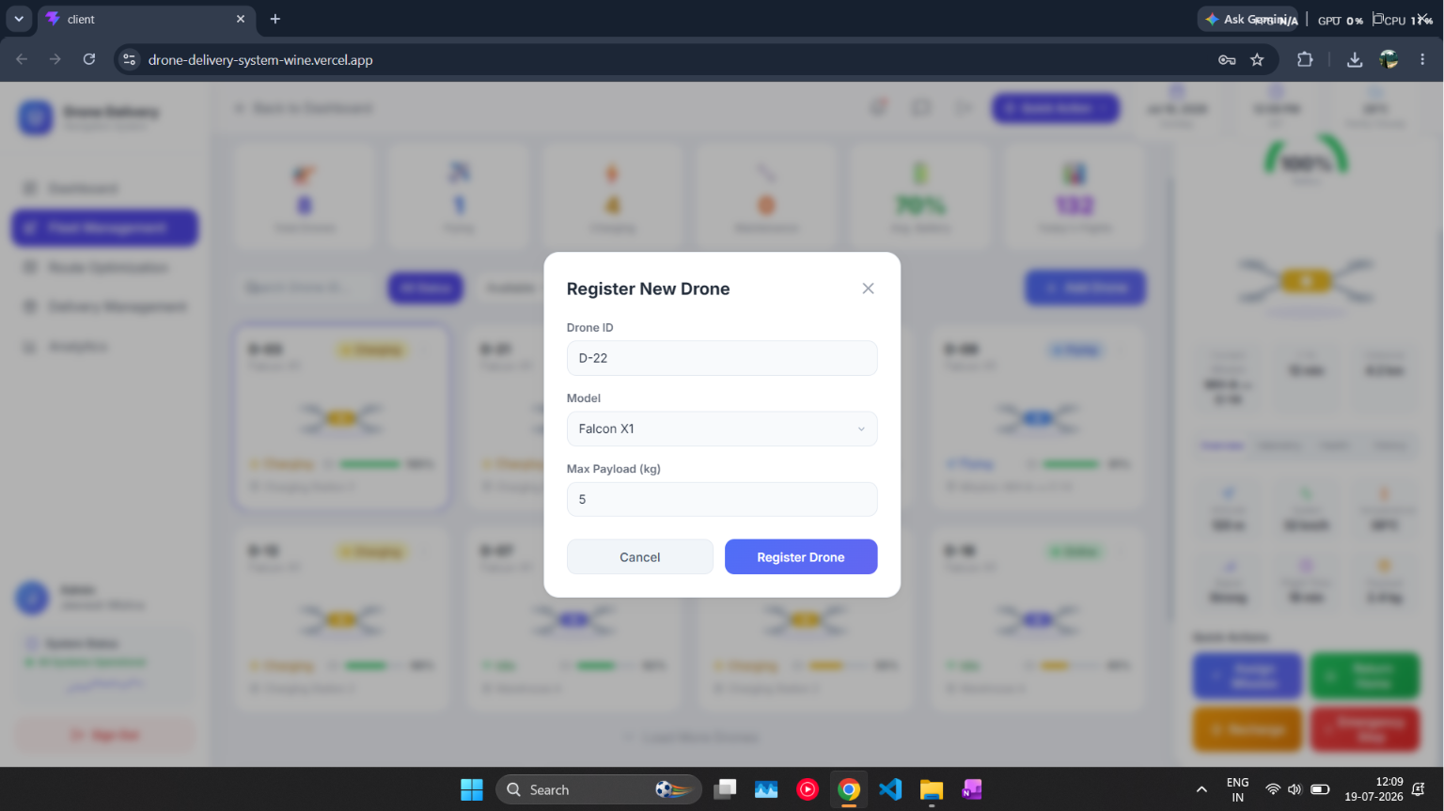
Description: This screenshot displays the Add Drone interface used to register a new drone in the Drone Delivery Navigation System. The administrator can enter all required information before adding a drone to the fleet.
The registration form contains the following fields:
- Drone ID
- Drone Model
- Maximum Payload
Before storing the information, the system validates all mandatory fields to ensure data accuracy. Once validated successfully, the drone details are stored securely in the MongoDB database and immediately become visible inside the Fleet Management dashboard.
This module makes drone registration simple, organized, and efficient while reducing manual errors during fleet expansion.
Figure 1.5: Route Optimization
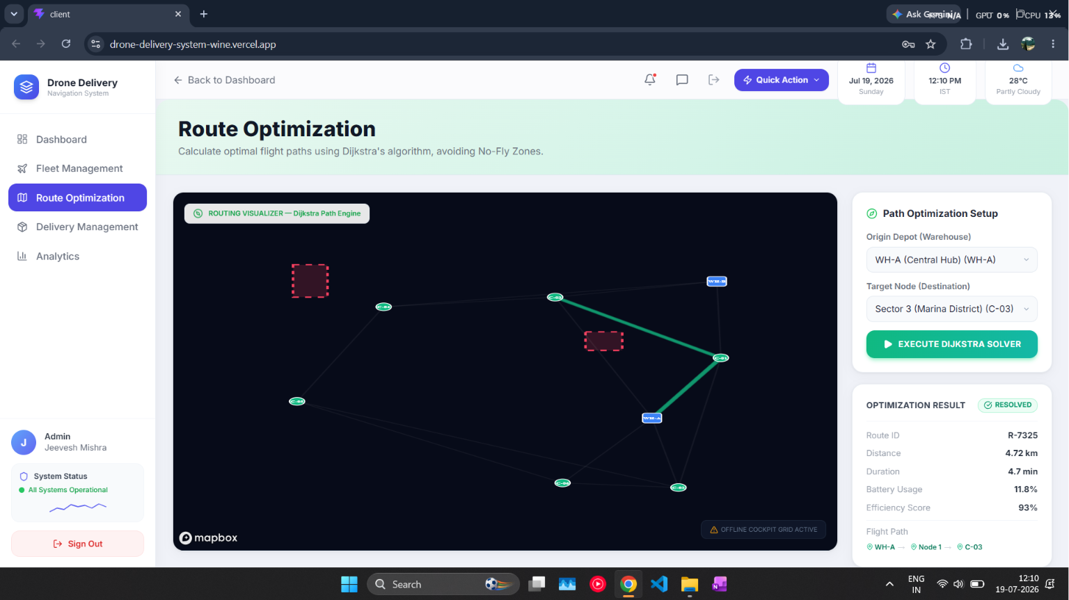
Description: This screenshot presents the Route Optimization Module of the Drone Delivery Navigation System. This module is responsible for calculating the shortest and most efficient delivery route between the warehouse and the destination. The application utilizes Dijkstra's Algorithm, one of the most popular shortest-path algorithms in graph theory.
Each delivery location is represented as a graph node, while the connecting roads or air paths are represented as weighted edges. The algorithm evaluates multiple possible routes and selects the one with the minimum total distance.
The optimized route helps in: Reducing delivery time , Saving drone battery , Improving operational efficiency , Increasing delivery success rate
The interactive map also provides a visual representation of the selected path, allowing administrators to monitor planned drone movement before dispatch.
The Route Optimization module demonstrates the practical implementation of Data Structures and Algorithms in solving real-world logistics problems.
Figure 1.6: Delivery Management
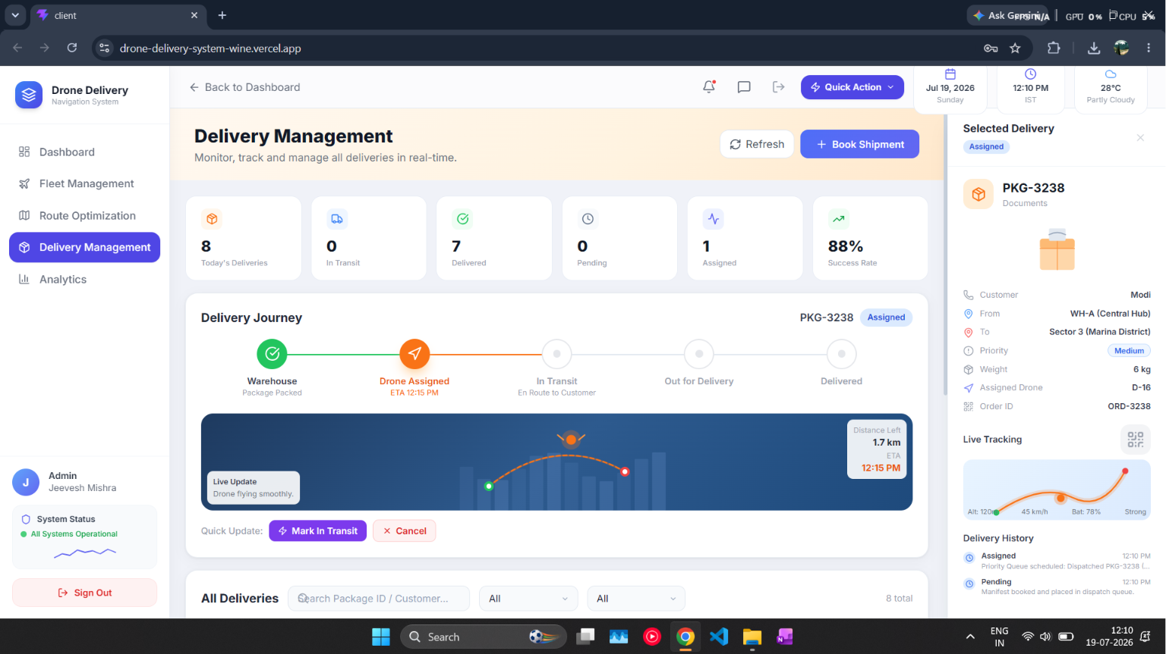
Description : This screenshot shows the Delivery Management Module of the Drone Delivery Navigation System. The Delivery Management page allows administrators to create, monitor, and manage package deliveries. Each delivery record contains important information including: Delivery ID , Customer Name , Pickup Location , Destination , , Assigned Drone , Delivery Priority , Current Status , Estimated Delivery Time.
The system enables administrators to quickly assign available drones to new delivery requests and continuously monitor the progress of each delivery. Status indicators such as Pending, Assigned, In Progress, Delivered, and Cancelled provide clear information regarding the current state of every delivery request. This module helps improve delivery coordination and ensures efficient package transportation.

Figure 1.7: Book Shipment Module
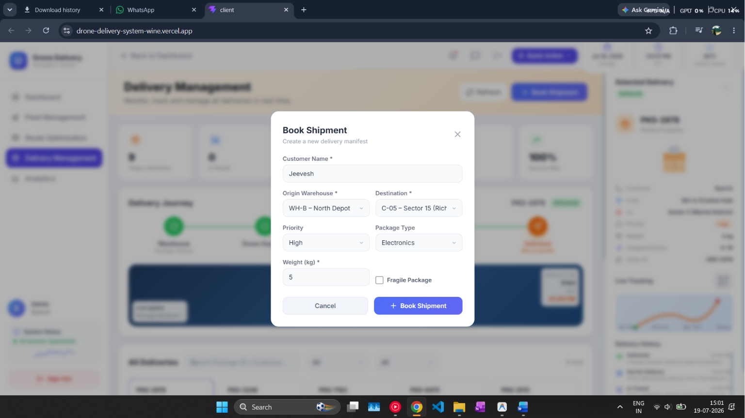
Description: This screenshot shows the Book Shipment module of the Drone Delivery Navigation System. This interface allows the administrator to create a new delivery request by entering all the necessary shipment information before assigning it to a drone.
The shipment booking form contains several important input fields, including: Customer Name, Origin Warehouse, Destination Location, Delivery Priority, Package Type, • Package Weight , Fragile Package Option.
The administrator can select the warehouse from which the package will be dispatched and specify the delivery destination. The system also allows the selection of different package categories such as Electronics, Documents, Medical Supplies, and other delivery items.
A Priority option is provided to classify deliveries as Low, Medium, or High priority. High-priority shipments are processed first by the delivery management system using a Priority Queue (Heap), ensuring that urgent deliveries receive immediate attention.
The Weight field is used to verify whether the selected drone can safely carry the package based on its payload capacity. Additionally, the Fragile Package checkbox enables special handling instructions for delicate items that require extra care during transportation.
After entering all required details, the administrator can click the "Book Shipment" button to register the delivery request. The shipment information is then stored in the MongoDB database and becomes available in the Delivery Management dashboard for drone assignment and live tracking.
This module simplifies the package booking process, reduces manual errors, and ensures that every shipment is properly documented before being assigned to a drone for delivery.

Figure 1.8: Priority Queue (Heap Dispatch)

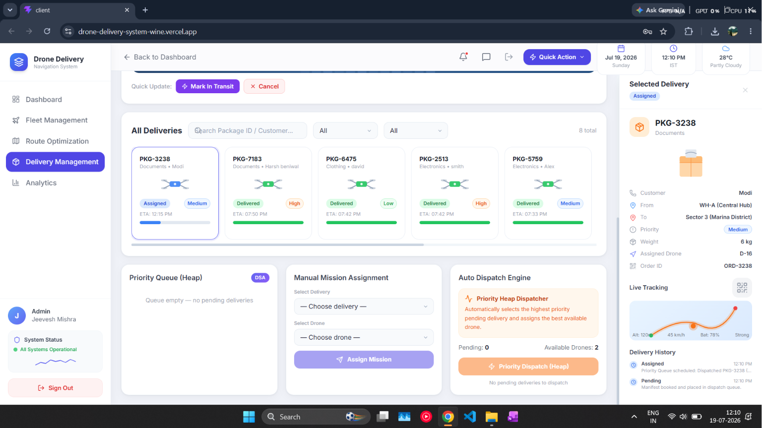

Description : This screenshot demonstrates the Priority Queue (Heap Dispatch) module of the Drone Delivery Navigation System. The module is responsible for automatically selecting the highest-priority delivery request and assigning it to the most suitable available drone.

The system uses the Heap Data Structure (Priority Queue) to organize pending delivery requests based on their priority levels. Instead of processing deliveries in the order they are received, the Priority Queue ensures that urgent deliveries are dispatched first.
The administrator can also manually assign deliveries using the Manual Mission Assignment section, where a delivery request and an available drone can be selected from the dropdown menus.

The Auto Dispatch Engine automatically analyzes all pending deliveries, checks drone availability, and recommends the best assignment. This intelligent approach minimizes delivery delays and improves fleet utilization.
The implementation of the Heap Data Structure significantly increases the efficiency of delivery scheduling and demonstrates the practical use of Data Structures and Algorithms in logistics management.

Figure 1.10: GitHub Repository

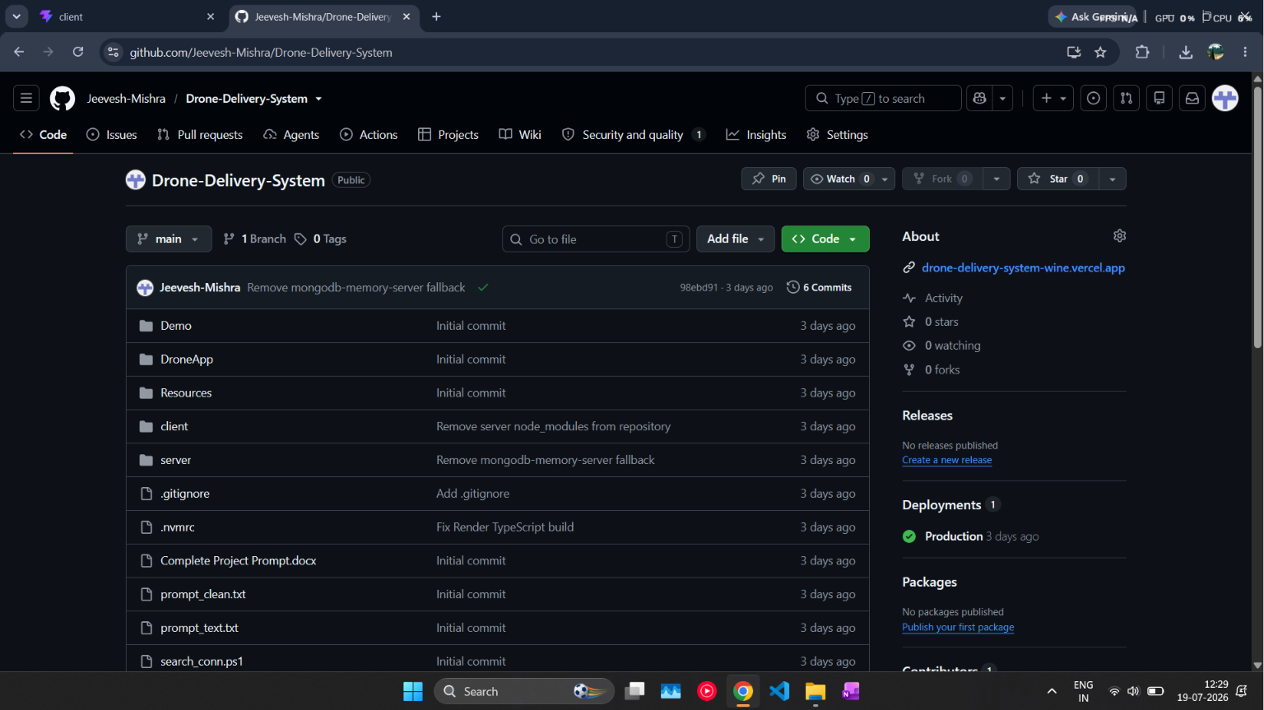

Description : This screenshot shows the GitHub repository of the Drone Delivery Navigation System.

GitHub was used as the primary version control platform during the development of this project. It helped in maintaining source code, tracking project progress, managing updates, and organizing both frontend and backend development.

The repository consists of multiple folders including: Client (React Frontend) , Server (Node.js Backend) , Resources , Demo Files.

The project also includes configuration files such as package.json, TypeScript configuration, environment files, and deployment settings.

GitHub made collaborative development easier by maintaining version history and allowing every modification to be tracked efficiently. It also serves as an online backup for the complete project source code.

Figure 1.11: Project Source Code
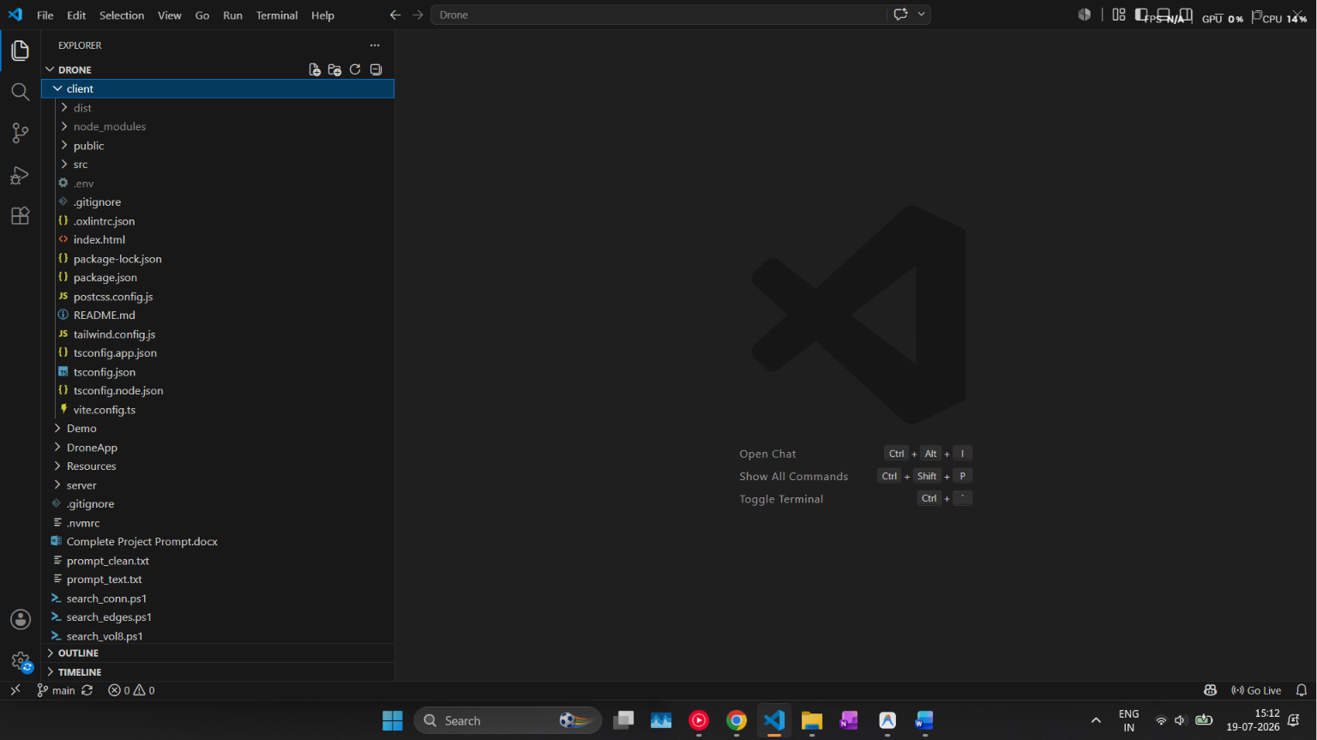

Description : This screenshot represents the complete source code of the Drone Delivery Navigation System developed using the MERN Stack.
The project is divided into two major sections:

Frontend
The frontend has been developed using React.js, TypeScript, Tailwind CSS, and Axios. It provides an interactive and responsive user interface for managing drones, deliveries, routes, and analytics.
Backend
The backend has been developed using Node.js, Express.js, and MongoDB. It handles user authentication, drone registration, route calculation, delivery management, and database operations.

The source code has been organized into separate folders for controllers, routes, middleware, database models, utility functions, and configuration files, making the application easier to maintain and extend.
The complete project source code is available at: https://drive.google.com/file/d/18quO38P2FoeRn6Xus47Qp07ixOpSXSq_/view?usp=sharing
FUTURE SCOPE

The Drone Delivery Navigation System can be enhanced in several ways to improve its functionality and make it suitable for real-world deployment.

Some future improvements include:
- AI-based route prediction using Machine Learning.
- Weather-based flight planning.
- Real-time GPS tracking using IoT devices.
- Mobile application for drone operators.
- Voice assistant integration.
- QR Code based package verification.
- Multi-warehouse delivery management.
- Automatic obstacle avoidance.
- Drone health monitoring.
- Live customer tracking portal.

These enhancements can significantly improve delivery accuracy, operational efficiency, and user experience.

PROJECT LINKS

Live Project
https://drone-delivery-system-wine.vercel.app

GitHub Repository
https://github.com/Jeevesh-Mishra/Drone-Delivery-System

Source Code
https://drive.google.com/file/d/18quO38P2FoeRn6Xus47Qp07ixOpSXSq_/view?usp=sharing

Conclusion

The Drone Delivery Navigation System was successfully developed as part of the Data Structure and Algorithm Bootcamp for Industry. The project provides an efficient platform for managing drone fleets, booking shipments, optimizing delivery routes, and monitoring deliveries in real time.

The application makes use of important Data Structures and Algorithms such as Graphs, Dijkstra's Algorithm, and Priority Queue (Heap) to improve route planning and delivery management. Modern web technologies including React.js, Node.js, Express.js, MongoDB, TypeScript, and Mapbox were used to build the application.

Through this project, I gained practical knowledge of full-stack web development, database management, API integration, and the implementation of Data Structures and Algorithms in solving real-world logistics problems. This project enhanced both my technical skills and problem-solving abilities and provided valuable hands-on experience in developing an industry-oriented application.

